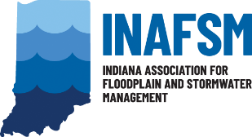
INAFSM Board of Directors Job Description
REGIONAL DIRECTOR

Duties as Stated in By-Laws: “The Regional Director is memberships’ direct contact and liaison between those regional members and the Board. The Regional Director shall be responsible for assisting the Floodplain and Stormwater Committee Chairs with their Education and Outreach efforts, the Legislative Chair with legislative issues and Membership Chair with membership outreach and recruitment in the respected Region of the state. The Regional Director shall perform all duties properly required by the Board and listed in the Regional Director’s job description. In the event that no nominations are received for the Regional Director position, the Chair shall reserve the right to appoint the Regional Director.”

Responsibilities:
- Attend all board meetings.
- Maintain knowledge of the organization and personal commitment to its goals and objectives.
- Represent INAFSM members located in respective region by acting as a direct, local INAFSM contact and liaison between those regional members and the INAFSM Board.
- Assist committee chairs by securing meeting or event locations within respective regions and help to promote those meetings and events in respective region.
- Prepares and submits written report to Board members prior to each Board meeting.
- Carry out special assignments as requested by the board chair.
- Participate as a vital part of the board leadership.
- Keeps job description and all Regional Director position documents up to date.

